Society Risk Assessment

Severity (S) | Likelihood (L) | Risk Factor (R) S x L= R
1 Negligible - all in a day's work | 1 Improbable | <4 LOW
2 Minor - minor injury with short term effect | 2 Remote - unlikely | 4-6 MEDIUM
3 Severe - major injury/disability (reportable) | 3 Possible - may or could well occur | > 8 HIGH
4 Extreme - fatal | 4 Probable - expected to occur, several times

What are the hazards? | Who might be harmed and how? | Initial assessment (before any controls) |  |  | Control measures – what are you already doing? | Residual risk (when controls in place) |  |  | What further actions are required? Do you need to do anything else? | By whom and when (date/deadline)
 |  | S | L | R |  | S | L | R
E.g. GDPR | Society Committee and Members | 3 | 2 | 6 | Ensure prior to the event we make all students aware these events are public and discourage any confidential or private information to be shared.  Committee members will attend the event and monitor the situation | 2 | 2 | 4 | If confidential information is given during events we can address this accordingly whilst supporting the event. | No deadline, ongoing task

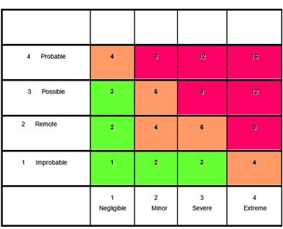

Date of Event | Society Name | Assessed By | Coordinators Signature
Name of Event | Location of Event | Description of Event

